Performance Table

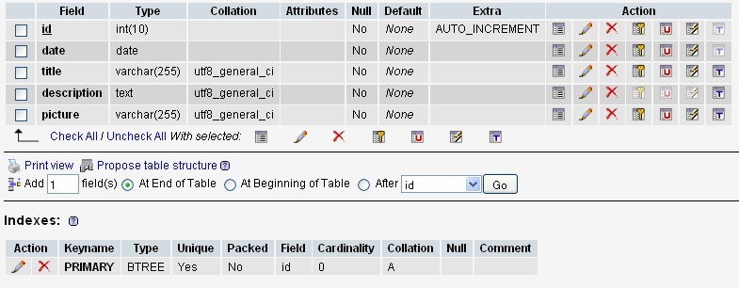
Id = unique sequence number, auto increment, primary key.
Date = performance date (yy-mm-dd)
Title = performance title
Description = performance description
Picture = performance picture file name as stored in data folder
Song Table

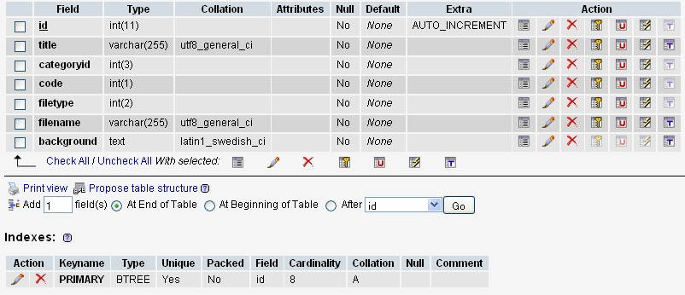

Id = unique sequence number, auto increment, primary key
Title = song title or cribcard title
Categoryid = song’s category
1 = Songs of working life
2 = Freedom from Oppression & Social Justice
3 = Peace
4 = Reconciliation
5 = Harmony with the environment
6 = Songs of farewell or remembrance
(this category could be dynamic = stored in category Table)
Code = public / member
1 = Public
2 = Member
File type = type of files
1 = audio
2 = lyric
3 = music sheet
4 = music sheet + audio
5 = cribcard
File Name = file name as it is stored in data folder
Background = Background description of the song
Member Table

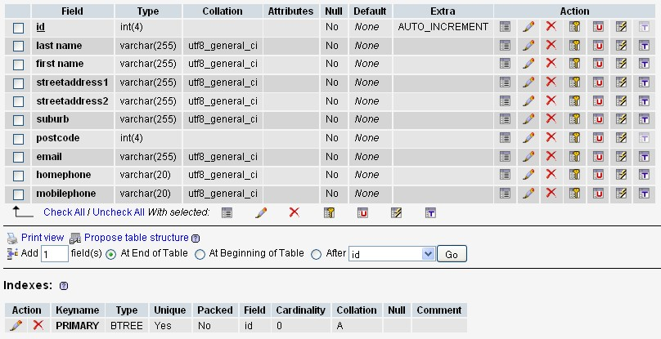

Id = unique sequence number, auto increment, primary key
Lastname = Member’s Last Name
Firstname = Member’s First Name
StreetAddress1 = Member’s home address 1
StreetAddress2 = Member’s home address 2
Suburb = Member’s home suburbname
Postcode = Member’s home postcode
Email = Member’s email address
Homephone = Member’s Home phone number
Mobilephone = Member’s Mobile Phone Number

